**Specification for ETL**

**from OMOP CDM v5 to PCORnet CDM v3**

Revision Date: April 7, 2016

**Versions**

|  |  |  |
| --- | --- | --- |
| **Date** | **Author** | **Note** |
| 4/7/2016 | Toan | Added the version table |
| 5/5/2016 | Don Torok | Added section for Death and Death Cause |

**dddst**

Table of Contents

Table of Contents 1

1.0 Introduction 4

2.0 Source Data Mapping Approach 4

3.0 Source Data Mapping 4

3.1 Data Mapping 4

3.1.1 Table: Demographic 4

3.1.2 Table: Enrollment 7

3.1.3 Table: Encounter 8

3.1.4 Table: Diagnosis 11

3.1.5 Table: Procedure 14

3.1.6 Table: Vital 15

3.1.7 Table: LAB_RESULT_CM 21

3.1.8 Table: CONDITION 25

3.1.9 Table: PRESCRIBING 27

3.1.10 Table: Death 28

3.1.11 Table: Death Cause 28

3.2 Appendix 2: OMOP CDM Version 5.0 ERD 30

4.0 Outstanding Issues 36

Outstanding Issues:

| Table | New in PCORnet CDM V3 | Comment | Status |
| --- | --- | --- | --- |
| All tables with date field | * Change from text to date * All tables have an ID field as primary key |  |  |
| Demographic | Hispanic   * The new categorical value of “Refuse to answer” has been added.   Sex   * The “Ambiguous” category may be used for individuals who are physically undifferentiated from birth. |  |  |
| Enrollment | No changes |  |  |
| Encounter | Enc_type   * The new categorical value of EI has been added.   Facility location   * Geographic location (3 digit zip code). Should be null if not recorded in source system (modification made from “blank” to “null” in v3.0).   Discharge_status, discharge_disposition, admitting_source will come from visit_occurrence  DRG will come from the Cost table. |  |  |
| Diagnosis | Dx Source in Condition Occurrence.condition status  Primary Diagnosis, one per encounter |  |  |
| Procedure | New column px_date; px_source |  |  |
| Vital | New vital source values  Smoking, tobacco and tobacco type |  |  |
| Lab_Result_CM |  | Needs review by group |  |
| Condition |  | Needs review by group |  |
| Prescribing | New table | Needs review by group |  |
| Dispensing |  | Needs review by group |  |
| Death | New Table | Needs to be added to doc |  |
| Death Condition | New Table | Needs to be added to doc |  |

# Introduction

The purpose of this document is to provide a mechanism for PCORnet data partners to communicate information about how they transformed data stored in OMOP Common Data Model (CDM) Version 5 format into the PCORnet Common Data Model (CDM) Version 3.0. To describe how the information will be used to help the PCORnet Coordinating Center better understand the transformation process, appropriate uses of the PCORnet data, and the comparability of data sources. This document details the approach used for the Extract, Transform, and Load (ETL) process to transform OMOP CDMv5 data elements to the data elements in the PCORnet CDM Version 3.0.

The document, 2015-06-01-PCORnet-Common-Data-Model-v3dot0-RELEASE.pdf, should be used in conjunction with this document, as the PCORnet Common Data Model has the data types and descriptions of the PCORnet tables.

This document assumes that the conventions outlined in CDRN Conventions for Populating OMOP CDM were followed in populating the OMOP CDMv5 database. It also requires that OMOP Vocabulary 5 or later be used for the ETL.

# Source Data Mapping Approach

This document describes mapping of the target PCORnet Common Data Model (CDM) tables and columns from source OMOP CDM model v5.

The mapping was designed based on OMOP CDM v5 specification, data samples, and PCORnet CDM specification. The mapping should provide sufficient information in order to design and develop ETL processes.

# Source Data Mapping

This section describes mapping process and ETL conversions for transforming data from an OMOP CDM (source) to a PCORNet CDM (destination).

## Data Mapping

Data mapping expects source and target data to be stored in any conventional relational database system per OMOP CDM v5 and PCORNet CDM v1 specifications respectively.

### Table: Demographic

PCORI DEMOGRAPHIC table contains one record per patient. Load Demographic data from OMOP Person table as described below.

.

Demographic field mapping:

| **Destination Field** | **Source Field** | **Applied Rule** | **Comment** |
| --- | --- | --- | --- |
| PATID | Person.Person_id |  | Convert to text |
| BIRTH_DATE | Use Person.year_of_birth, month_of_birth and day_of_birth to construct date as text in 'YYYY-MM-DD' format. Substitute month and day (each) as '01' if not available in the source. | Format date as text 'YYYY-MM-DD'. |  |
| BIRTH_TIME | Person.time_of_birth | Use NULL if not available | Convert to text format ‘HH:MI’ using 24-hour clock and zero-padding for hour and minute |
| SEX | Person.gender_concept_id | |  |  | | --- | --- | | OMOP to PCORnet | | | 44814664 | A = Ambiguous | | 8532 | F = Female | | 8507 | M = Male | | 44814650 | NI = No information | | 44814653 | UN = Unknown | | 44814649 | OT = Other | | 0 | NULL | | |  |  | | --- | --- | | OMOP Concepts | | | 44814664 | Ambiguous | | 8532 | Female | | 8507 | Male | | 44814650 | No Information | | 44814653 | Unknown | | 44814649 | Other | | 0 | Field does not exist in the source | |
| HISPANIC | Derive from Person.ethnicity_concept_id | |  |  | | --- | --- | | OMOP to PCORnet | | | 38003563 | Y = Yes | | 38003564 | N = No | | 44814650 | NI = No information | | 44814653 | UN = Unknown | | 44814649 | OT = Other | | 0 | NULL | | |  |  | | --- | --- | | OMOP Concepts | | | 38003563 | Hispanic or Latino | | 38003564 | Not Hispanic or Latino | | 44814650 | No Information | | 44814653 | Unknown | | 44814649 | Other | | 0 | Field does not exist in the source | |
| RACE | Derive from Person.Race_Concept_id |  | The mapping for Race from OMOP to PCORnet is given in a table below. |
| BIOBANK_FLAG | Observation.value_as_concept_id | If at least one record in Specimen table for the patient exist or  in the Observation table observation_concept_id is 4001345 (Biobank flag) with  value_as_concept_id = 4188539 (Yes) then set biobank_flag as ‘Y’  else ‘N’ | The allowable values are ‘Y’ or ‘N’. The absence of a record indicates that there are no biobank specimens. |
| RAW_SEX | Person.gender_source_value |  |  |
| RAW_ HISPANIC | Person.ethnicity_source_value |  |  |
| RAW_RACE | Person.race_source_value |  |  |

OMOP to PCORnet Race Mapping

| **OMOP** | | **PCORnet** |
| --- | --- | --- |
| **concept** | **description** | **Value** |
| 38003600 | African | 03 = Black or African American |
| 38003599 | African American | 03 = Black or African American |
| 38003573 | Alaska Native | 01 = American Indian or Alaska Native |
| 38003572 | American Indian | 01 = American Indian or Alaska Native |
| 8657 | American Indian or Alaska Native | 01 = American Indian or Alaska Native |
| 38003616 | Arab | 05 = White |
| 8515 | Asian | 02 = Asian |
| 38003574 | Asian Indian | 02 = Asian |
| 38003601 | Bahamian | 03 = Black or African American |
| 38003575 | Bangladeshi | 02 = Asian |
| 38003602 | Barbadian | 03 = Black or African American |
| 38003576 | Bhutanese | 02 = Asian |
| 38003598 | Black | 03 = Black or African American |
| 8516 | Black or African American | 03 = Black or African American |
| 38003577 | Burmese | 02 = Asian |
| 38003578 | Cambodian | 02 = Asian |
| 38003579 | Chinese | 02 = Asian |
| 38003604 | Dominica Islander | 03 = Black or African American |
| 38003603 | Dominican | 03 = Black or African American |
| 38003614 | European | 05 = White |
| 38003581 | Filipino | 02 = Asian |
| 38003605 | Haitian | 03 = Black or African American |
| 38003582 | Hmong | 02 = Asian |
| 38003583 | Indonesian | 02 = Asian |
| 38003593 | Iwo Jiman | 02 = Asian |
| 38003606 | Jamaican | 03 = Black or African American |
| 38003584 | Japanese | 02 = Asian |
| 38003585 | Korean | 02 = Asian |
| 38003586 | Laotian | 02 = Asian |
| 38003597 | Madagascar | 02 = Asian |
| 38003587 | Malaysian | 02 = Asian |
| 38003594 | Maldivian | 02 = Asian |
| 38003612 | Melanesian | 04 = Native Hawaiian or OtherPacific Islander |
| 38003611 | Micronesian | 04 = Native Hawaiian or OtherPacific Islander |
| 38003615 | Middle Eastern or North African | 05 = White |
| 8557 | Native Hawaiian or Other Pacific Islander | 04 = Native Hawaiian or OtherPacific Islander |
| 38003595 | Nepalese | 02 = Asian |
| 38003588 | Okinawan | 02 = Asian |
| 38003613 | Other Pacific Islander | 04 = Native Hawaiian or OtherPacific Islander |
| 38003589 | Pakistani | 02 = Asian |
| 38003610 | Polynesian | 04 = Native Hawaiian or OtherPacific Islander |
| 38003596 | Singaporean | 02 = Asian |
| 38003590 | Sri Lankan | 02 = Asian |
| 38003580 | Taiwanese | 02 = Asian |
| 38003591 | Thai | 02 = Asian |
| 38003607 | Tobagoan | 03 = Black or African American |
| 38003608 | Trinidadian | 03 = Black or African American |
| 38003592 | Vietnamese | 02 = Asian |
| 38003609 | West Indian | 03 = Black or African American |
| 8527 | White | 05 = White |
| 44814659 | Multiple Race | 06 = Multiple Race |
| 44814660 | Refuse to answer | 07 = Refuse to answer |
| 44814650 | No Information | NI = No information |
| 44814653 | Unknown | UN = Unknown |
| 44814649 | Other | OT = Other |
| 0 | Field does not exist in the source | NULL |

### Table: Enrollment

The ENROLLMENT table has a start/stop structure that contains records for continuous enrollment periods.

“Enrollment” is an insurance-based concept that defines a period during which all medically-attended events are expected to be observed. For partners that do not have enrollment information for some of their patients, other approaches for identifying periods during which complete medical capture is expected can be used.

This table is designed to identify periods during which a person is expected to have complete data capture. Members with medical coverage, drug coverage, or both should be included.

A record is expected to represent a unique combination of PATID, ENR_START_DATE.

*Currently OMOP CDM is using the earliest and latest encounter dates (‘E’), which is in violation of the PCORnet requirement. This is to be discussed with PCORnet.*

Enrollment field mapping:

| **Destination Field** | **Source Field** | **Applied Rule** | **Comment** |
| --- | --- | --- | --- |
| PATID | Observation_Period.person_id |  | Convert to text |
| ENR_START_DATE | Observation_Period.observation_period_start_date | Convert to text formatted as 'YYYY-MM-DD' |  |
| ENR_END_DATE | Observation_Period.observation_period_end_date | Convert to text formatted as 'YYYY-MM-DD' |  |
| CHART | Observation.value_as_concept_id where observation_type_concept_id = 4030450 (Patient chart) | Join to Observation table on person_id, observation_start_date and observation_type_concept_id = 4030450 (Patient chart). If the value_as_concept_id = 4188539 (Yes) then ‘Y’ else ‘N’ | The absence of an Observation record for a person for an Observation Period will be interpreted as No. |
| ENR_BASIS | Observation_Period.period_type_concept_id | |  |  | | --- | --- | | OMOP to PCORnet | | | 44814722 | I = Insurance | | 44814723 | G = Geography | | 44814725 | A = Algorithmic | | 44814724 | E = Encounter Based | | |  |  | | --- | --- | | OMOP Concepts | | | 44814722 | Insurance | | 44814723 | Geography | | 44814725 | Algorithmic | | 44814724 | Encounter Based | |

### Table: Encounter

The ENCOUNTER Table contains one record per PATID and ENCOUNTERID (which reflects a unique combination of PATID, ADMIT_DATE, PROVIDERID and ENC_TYPE).

The encounter table should include information on interactions between patients and providers. Each diagnosis and procedure recorded during the encounter should have a separate record in the Diagnosis or Procedure Tables.

Multiple visits to the same provider on the same day may be considered one encounter (especially if defined by a reimbursement basis); if so, the ENCOUNTER record should be associated with all diagnoses and procedures that were recorded during those visits.

Encounter field mapping:

| **Destination Field** | **Source Field** | **Applied Rule** | **Comment** |
| --- | --- | --- | --- |
| PATID | Visit_Occurrence.person_id |  | Convert to text |
| ENCOUNTERID | Visit_Occurrence.visit_occurrence_id |  |  |
| ADMIT_DATE | Visit_Occurrence.visit_start_date | Text. Format as 'YYYY-MM-DD'. |  |
| ADMIT_TIME | Visit_Occurrence.visit_start_time | If available format as ‘hh:mm:ss’ military time otherwise is should be NULL |  |
| DISCHARGE_DATE | Visit_Occurrence.visit_end_date | Text. Format as 'YYYY-MM-DD'. |  |
| DISCHARGE_TIME | Visit_Occurrence.visit_end_time | If available format as ‘hh:mm:ss’ otherwise is should be NULL |  |
| PROVIDERID | Visit_Occurrence.provider_id |  |  |
| FACILITY_LOCATION | Location.zip | Join Visit_Occurrence to Care_Site on care_site_id, then to Location on location_id. NULL if it cannot be derived. | Only if zipcode is available. Otherwise NULL  3-digit zip for PCORNet |
| ENC_TYPE | Visit_Occurrence.visit_concept_id | |  |  | | --- | --- | | OMOP to PCORnet | | | 9201 | IP = Inpatient Hospital Stay | | 9202 | AV = Ambulatory Visit | | 9203 | ED = Emergency Department | | 42898160 | IS = Non-Acute Institutional Stay | | 44814710 | IS = Non-Acute Institutional Stay | | 44814711 | OA = Other Ambulatory Visit | | 44814650 | NI = No information | | 44814653 | UN = Unknown | | 44814649 | OT = Other | | 0 | NULL | | |  |  | | --- | --- | | OMOP Concepts | | | 9201 | Inpatient Visit | | 9202 | Outpatient Visit | | 9203 | Emergency Room Visit | | 42898160 | Long Term Care Visit | | 44814710 | Non-Acute Institutional Stay | | 44814711 | Other ambulatory visit | | 44814650 | No information | | 44814653 | Unknown | | 44814649 | Other | | 0 | Field does not exist in the source | |
| FACILITYID | Visit_Occurrence.care_site_id |  |  |
| DISCHARGE_DISPOSITION | Based on Observation.value_as_concept_id – see Applied Rule column | Join to Observation table on visit_occurrence_id and observation_concept_id = 44813951 (Discharge details). The mapping below is based on the value_as_concept_id:   |  |  | | --- | --- | | OMOP to PCORnet | | | 4161979 | A = Discharged alive | | 4216643 | E = Expired | | 44814650 | NI = No information | | 44814653 | UN = Unknown | | 44814649 | OT = Other | | 0 | NULL | | |  |  | | --- | --- | | OMOP Concepts | | | 4161979 | Discharged alive | | 4216643 | Patient died | | 44814650 | No Information | | 44814653 | Unknown | | 44814649 | Other | | 0 | Field does not exist in the source | |
| DISCHARGE_STATUS | Based on Observation.value_as_concept_id – see Applied Rule column | Join to Observation table on visit_occurrence_id and observation_ concept_id = 4137274 (Discharge to establishment). The mapping below is based on the value_as_concept_id:   |  |  | | --- | --- | | OMOP to PCORnet | | | 38004205 | AF = Adult Foster Home | | 38004301 | AL = Assisted Living Facility | | 4021968 | AM = Against Medical Advice | | 44814693 | AW = Absent without leave | | 4216643 | EX = Expired | | 38004195 | HH = Home Health | | 8536 | HO = Home / Self Care | | 8546 | HS = Hospice | | 38004279 | IP = Other Acute Inpatient Hospital | | 8676 | NH = Nursing Home (Includes ICF) | | 8920 | RH = Rehabilitation Facility | | 44814680 | RS = Residential Facility | | 8717 | SH = Still In Hospital | | 8863 | SN = Skilled Nursing Facility | | 44814650 | NI = No information | | 44814653 | UN = Unknown | | 44814649 | OT = Other | | 0 | NULL | | |  |  | | --- | --- | | OMOP Concepts | | | 38004205 | Agencies, Foster Care Agency | | 38004301 | Nursing & Custodial Care Facilities, Assisted Living Facility | | 4021968 | Patient self-discharge against medical advice | | 44814693 | Absent without leave | | 4216643 | Patient died | | 38004195 | Agencies, Home Health | | 8536 | Home | | 8546 | Hospice | | 38004279 | Hospitals, General Acute Care Hospital | | 8676 | Nursing Facility | | 8920 | Comprehensive Inpatient Rehabilitation Facility: | | 44814680 | Residential Facility | | 8717 | Inpatient Hospital | | 8863 | Skilled Nursing Facility | | 44814650 | No information | | 44814653 | Unknown | | 44814649 | Other | | 0 | No matching concept | |
| DRG | Observation.Value_as_concept_id | Look for observation record associated with the visit with observation_concept_id = 3040464 (Hospital discharge DRG). If the record is not found or value_as_concept_id is 44814650 or 44814649 use NULL.  Only populate for IP (Inpatient), IS (Non-Acute Institutional Stay) and ED (Emergency Department) encounters. Use NULL for other encounter types. | Concepts from vocabulary_id = ‘DRG’ or   |  |  | | --- | --- | | OMOP Concepts | | | 44814650 | No information | | 44814649 | Other | |
| DRG_TYPE | See Applied Rule | OMOP CDMv5 does not have this information. Use the appropriate value from the vocabulary below:  01 = CMS-DRG (old system)  02 = MS-DRG (current system)  NI = No information  UN = Unknown  OT = Other | 02- double check |
| ADMITTING_SOURCE | Based on Observation.value_as_concept_id | Join to Observation table on visit_occurrence_id and observation_concept_id = 4145666 (Admission from Establishment). The mapping below is based on the value_as_concept_id:   |  |  | | --- | --- | | OMOP to PCORnet | | | 38004205 | AF = Adult Foster Home | | 38004195 | HH = Home Health | | 38004207 | AV = Ambulatory Visit | | 8920 | RH = Rehabilitation Facility | | 8870 | ED = Emergency Department | | 8536 | HO = Home / Self Care | | 8546 | HS = Hospice | | 38004279 | IP = Other Acute Inpatient Hospital | | 38004301 | AL = Assisted Living Facility | | 8676 | NH = Nursing Home (Includes ICF) | | 44814680 | RS = Residential Facility | | 8863 | SN = Skilled Nursing Facility | | 44814650 | NI = No information | | 44814653 | UN = Unknown | | 44814649 | OT = Other | | 0 | NULL | | |  |  | | --- | --- | | OMOP Concepts | | | 38004205 | Agencies, Foster Care Agency | | 38004195 | Agencies, Home Health | | 38004207 | Ambulatory Health Care Facilities, Clinic/Center, Ambulatory Surgical | | 8920 | Comprehensive Inpatient Rehabilitation Facility | | 8870 | Emergency Room - Hospital | | 8536 | Home | | 8546 | Hospice | | 38004279 | Hospitals, General Acute Care Hospital | | 38004301 | Nursing & Custodial Care Facilities, Assisted Living Facility | | 8676 | Nursing Facility | | 44814680 | Residential facility | | 8863 | Skilled Nursing Facility | | 44814650 | No Information | | 44814653 | Unknown | | 44814649 | Other | | 0 | Field does not exist in the source | |
| RAW_ ENC_TYPE | Visit_Occurrence.visit_source_value |  |  |
| RAW_ DISCHARGE_DISPOSITION | Observation.observation_source_value | Join to Observation table on visit_occurrence_id and observation_type_concept_id = 44813951 (Discharge details).  If data is not available populate with NULL. |  |
| RAW_ DISCHARGE_STATUS | Observation.observation_source_value | Join to Observation table on visit_occurrence_id and observation_type_concept_id = 4137274 (Discharge to establishment). If data is not available populate with NULL. |  |
| RAW_ DRG_TYPE | NULL |  |  |
| RAW_ ADMITTING_SOURCE | Observation.observation_source_value | Join to Observation table on visit_occurrence_id and observation_type_concept_id = 4145666 (Admission from Establishment). |  |

### Table: Diagnosis

DIAGNOSIS should capture all uniquely recorded diagnoses for all encounters, except those generated from problem lists. If a patient has multiple diagnoses associated with one encounter, then there should be one record in this table for each diagnosis. Exclude records from the OMOP CDM where the Condition Type Concept is EHR problem list entry (38000245).

If a local ontology is used, but cannot be mapped to a standard ontology such as ICD-9-CM, DX_TYPE should be populated as “Other”.

Note: The admit date for the diagnosis is copied from the encounter record which is the admission or appointment date, where in the OMOP CDM, the condition occurrence date is when the condition was defined. Therefore, it is possible that there will be more than one of the same diagnoses during a visit in the OMOP CDM. Duplicate records are also possible due to the mapping of one source code to multiple standard codes. These duplicated diagnoses should be reduced to a single record in PCORnet based on the following attributes: Condition_Occurrence.visit_occurrence_id, Condition_Occurrence.condition_source_value, Condition_Occurrence.condition_type_concept_id, and related Observation.value_as_concept_id (for Observation.concept_id = 4021918. ‘Qualifier for type of diagnosis).

Diagnosis field mapping:

| **Destination Field** | **Source Field** | **Applied Rule** | **Comment** |
| --- | --- | --- | --- |
| PATID | Condition_Occurrence.person_id |  | Convert to text |
| ENCOUNTERID | Condition_Occurrence.visit_occurrence_id |  |  |
| ENC_TYPE | Encounter.enc_type | Join to [target] Encounter table on Condition_Occurrence.visit_occurrence_id = Encounter.encounterid | Copied from ENCOUNTER record |
| ADMIT_DATE | Encounter.admit_date | Join to Encounter table on Condition_Occurrence.visit_occurrence_id = Encounter.encounterid | Text. Format as 'YYYY-MM-DD'.  Copied from ENCOUNTER record |
| PROVIDERID | Encounter.provider_id | Join to encounter table on Condition_Occurrence.visit_occurrence_id = Encounter.providerid | Copied from ENCOUNTER record |
| DX | Condition_Occurrence.condition_source_value  Otherwise,  Concept.concept_code | If condition_ source_concept_id is 44814649 (‘Other’), use Condition_Occurrence.condition_source_value.  Otherwise,  join condition_ source_concept_id to Concept.concept_id. | PCORnet expects to see all diagnosis codes as they were represented in the source system. Therefore, use source_concept_id or source_value to represent DX in the source coding system. |
| DX_TYPE | Derive from Concept.vocabulary_id | Join source_condition_concept_id to Concept.concept_id to get vocabulary_id   |  |  | | --- | --- | | OMOP to PCORnet Vocabulary Mapping | | | ICD9CM | 09 = ICD-9-CM | | ICD10CM | 10 = ICD-10-CM | | SNOMED | SM = SNOMED CT | | PCORNet | OT = Other |   Otherwise  use ‘OT’ (‘Other’) | |  | | --- | | OMOP Vocabularies | | ICD9CM | | ICD10CM | | SNOMED | | PCORNet | |
| DX_SOURCE | Derive from  Condition_Occurrence.condition_status_concept_id | |  |  | | --- | --- | | OMOP to PCORnet | | | 4203942 | AD = Admitting | | 4230359 | FI = Final/Discharge | | 4033240 | IN = Interim | | 44814650 | No Information | | 44814653 | Unknown | | 44814649 | Other |   If record does not exist, then NULL. | |  |  | | --- | --- | | OMOP Concepts | | | 4203942 | Admitting diagnosis | | 4230359 | Final/Discharge diagnosis | | 4033240 | Preliminary diagnosis | | 44814650 | No Information | |  | Unknown | | 44814649 | Other | |
| PDX | Derive from Condition_Occurrence.condition_type_concept_id | If condition_type_concept_id = 44786627  Then 'P' (Principal)  Else If condition_type_concept_id =  44786629  Then 'S' (Secondary)  Else  If respective Visit_Occurrence.visit_concept_id are  9202 (Outpatient Visit)  9203 (Emergency Room Visit)  44814711 (Other ambulatory visit)  Then ‘X’ (Unable to Classify)  Else   |  |  | | --- | --- | | OMOP to PCORnet | | | 44814650 | No Information | | 44814653 | Unknown | | 44814649 | Other | | Only Primary Condition (44786627)  and Secondary Condition(44786629)  are relevant. Also, relevant only to IS and IP encounter types. |
| RAW_DX | Condition_Occurrence.condition_source_value |  | Load source values 'as is' - with source-specific suffixes and prefixes. |
| RAW_ DX_TYPE | Concept.vocabulary_id | If condition_ source_concept_id is 44814649 (‘Other’), use ‘OT’ (‘Other’).  Otherwise, join condition_source_concept_id to Concept.concept_id |  |
| RAW_ DX_SOURCE | Condition.condition_status_source_value | Join to Fact_Relationship table on  fact_id_1 = condition_occurrence_id  domain_concept_id_1 = 19  domain_concept_id_2 = 27  relationship_concept_id = 0  and Observation table on  fact_id_2 = observation_id  and observation_concept_id is Qualifier for type of diagnosis (4021918) |  |
| RAW_ PDX | Concept.concept_name | If condition_type_concept_id IN(44786627, 44786629 ) join to Concept.concept_id  Otherwise  NULL | Primary Condition (44786627)  Secondary Condition (44786629) |

### Table: Procedure

The PROCEDURE Table contains one record per unique combination of PATID, ENCOUNTERID, PX, and PX_TYPE. Because the date in the procedure table is that of the encounter, not necessarily when the procedure was performed, there may be multiples of the same procedure for the person/encounter/date when selecting from the OMOP procedure table. Duplicate records are also possible due to the mapping of one source code to multiple standard codes. These duplicated procedure records should be reduced to a single record in PCORnet based on procedure_occurrence.visit_occurrence_id and procedure_occurrence. procedure_source_value.

In OMOP CDM Procedure_Occurrence.visit_occurrence_id is optional, however PCORNet CDM specification requires mandatory encounter id for DIAGNOSIS and PROCEDURE. Exclude procedures where the visit_occurrence_id is NULL.

Procedure field mapping:

| **Destination Field** | **Source Field** | **Applied Rule** | **Comment** |
| --- | --- | --- | --- |
| PATID | Procedure_Occurrence.person_id |  | Convert to text |
| ENCOUNTERID | Procedure_Occurrence.visit_occurrence_id |  | . |
| ENC_TYPE | Encounter.enc_type | Join to [target] Encounter table on Procedure_Occurrence.visit_occurrence_id = Encounter.encounterid | Copied from ENCOUNTER record |
| ADMIT_DATE | Encounter.admit_date | Join to Encounter table on Procedure_Occurrence.visit_occurrence_id = Encounter.encounterid | Text. Format as 'YYYY-MM-DD'.  Copied from ENCOUNTER record |
| PROVIDERID | Encounter.provider_id | Join to encounter table on Procedure_Occurrence.visit_occurrence_id = Encounter.providerid | Copied from ENCOUNTER record. |
| PX | procedure_occurrence.procedure_source_value  Otherwise  Concept.concept_code | If procedure_source_concept_id is 44814649 (‘Other’), use procedure_occurrence. procedure_source_value.  Otherwise  join procedure_ source_concept_id to Concept.concept_id. | PCORnet expects to see all procedure codes as they were represented in the source system. Therefore, use source_concept_id or source_value to represent PX in the source coding system. |
| PX_TYPE | Derive from Concept.vocabulary_id | Join procedure_source_concept_id to Concept.concept_id to get vocabulary_id   |  |  | | --- | --- | | OMOP to PCORnet Vocabulary Mapping | | | ICD9CM | 09 = ICD-9-CM | | ICD9Proc | 09 = ICD-9-CM | | ICD10PCS | 10 = ICD-10-PCS | | CPT4 | C4 = CPT-4 (i.e., HCPCS Level I) | | HCPCS | HC = HCPCS (i.e., HCPCS Level II) | | LOINC | LC = LOINC | | NDC | ND = NDC | | Revenue Code | RE = Revenue | | PCORNet | OT = Other |   Otherwise  Use ‘OT’ (‘Other’). | |  | | --- | | OMOP Vocabulary Codes | | ICD9CM | | ICD9Proc | | ICD10PCS | | CPT4 | | HCPCS | | LOINC | | NDC | | Revenue Code | | PCORNet | |
| RAW_PX | Procedure_Occurrence.procedure_source_value |  |  |
| RAW_PX_TYPE | Concept.concept_id | If source_condition_concept_id is 44814649 (‘Other’), use ‘OT’ (‘Other’).  Otherwise, join procedure_source_concept_id to Concept.concept_id |  |

### Table: Vital

Multiple measurements per encounter can be populated (for example, 3 blood pressure readings). There will be records where not all the vital statistics are defined. Create a record any time there is at least one of the attributes, weight, blood pressure, height or BMI is defined.

Vital signs data are sourced from OMOP Measurement and Observation tables.

Records corresponding to one visit may be grouped into one Vital record or represented as one Vital record per one vital sign.

Systolic and diastolic blood pressure coming from the same measurement must be by grouped into one record by utilizing Fact_Relationship link between the two records in the Measurement table as follows. Fact_id_1 and fact_id_2 should be equal to the respective measurement_id of diastolic and systolic BP records. Domain_concept_id_1 and domain_concept_id_2 should be equal to 21 (‘Measurement’). Relationship_concept_id should be equal to 46233682 (‘Diastolic to systolic blood pressure measurement’).

OMOP Measurement to PCORnet VITAL field mapping:

| **Destination Field** | **Source Field** | **Applied Rule** | **Comment** |
| --- | --- | --- | --- |
| PATID | Measurement.person_id |  | Convert to text |
| ENCOUNTERID | Measurement.visit_occurrence_id  or  NULL |  | Arbitrary encounter-level identifier. This is an optional relationship; the ENCOUNTERID should be present if the vitals were measured as part of healthcare delivery: Measurement.measurement_type_concept_id = ‘Observation Recorded from EHR’ (38000276). |
| MEASURE_DATE | Measurement. measurement_date | Text. Format as 'YYYY-MM-DD'. |  |
| MEASURE_TIME | Measurement.measurement_time | Text. Format as 'HH:MI' as 24 hours clock with zero-padding for hours and minutes. |  |
| VITAL_SOURCE | Measurement. measurement_type_concept_id | |  |  | | --- | --- | | OMOP to PCORnet | | | 44814721 | PR = Patient-reported | | 38000276 | HC = Healthcare delivery setting | | All other codes | OT = Other | | Relevant OMOP concepts are: ‘Patient reported’ (44814721) or ‘Observation Recorded from EHR’ (38000276).  If multiple vital signs are compiled together in one record, Measurement.measurement_Type_Concept_ID must be the same. |
| HT | Measurement.value_as_number | Where Measurement .measurement_concept_id = 3036277 (Body height)  Parse the string and convert to inches. | Have to parse string which is in format of 9’9.9’’ to inches. |
| WT | Measurement.value_as_number | Where Measurement .measurement_concept_id = 3025315 (Body weight)  Divided by 16 to get pounds | Have to convert from ounces to pounds. Round to pounds. |
| DIASTOLIC | Measurement.value_as_number | Where Measurement .measurement_concept_id in (3012888, 3034703, 3019962, 3013940 ) |  |
| SYSTOLIC | Measurement.value_as_number | Where Measurement .measurement_concept_id in (3004249, 3018586, 3035856, 3009395 ) |  |
| ORIGINAL_BMI | Measurement.value_as_number | Where Measurement .measurement_concept_id = 3038553 (Body mass index) |  |
| BP_POSITION | derived from Measurement.measurement_concept_id | |  |  |  | | --- | --- | --- | | Concept | Description | PCORnet Value | | 3034703 | Diastolic Blood Pressure - Sitting | ‘01’ | | 3019962 | Diastolic Blood Pressure - Standing | ‘02’ | | 3013940 | Diastolic Blood Pressure - Supine | ‘03’ | | 3012888 | Diastolic BP | ‘NI’ | | 3018586 | Systolic Blood Pressure - Sitting | ‘01’ | | 3035856 | Systolic Blood Pressure - Standing | ‘02’ | | 3009395 | Systolic Blood Pressure - Supine | ‘03’ | | 3004249 | Systolic BP | ‘NI’ |   NULL if no blood pressure reading in this record. | Position when blood pressure taken is derived from the diastolic and systolic code provided. |
| RAW_ VITAL_SOURCE | Measurement.measurement_source_value | Derived from Measurement. measurement_Type_Concept_ID for a respective vital sign.  Measurement.measurement_Type_Concept_ID values:   |  |  | | --- | --- | | OMOP to PCORnet | | | 44814721 | Patient-reported | | 38000276 | Healthcare delivery setting | | All other codes | Other | | If multiple vital signs are compiled together in one record, Observation.Observation_Type_Concept_ID must be the same. |
| RAW_ DIASTOLIC | Measurement.measurement_source_value | Where Measurement .measurement_concept_id in (3012888, 3034703, 3019962, 3013940 ) | |  |  | | --- | --- | | OMOP Concepts | | | 3012888 | BP diastolic | | 3034703 | Diastolic blood pressure--sitting | | 3019962 | Diastolic blood pressure--standing | | 3013940 | Diastolic blood pressure--supine | |
| RAW_ SYSTOLIC | Measurement.measurement_source_value | Measurement .measurement_concept_id in (3004249, 3018586, 3035856, 3009395 ) | |  |  | | --- | --- | | OMOP Concepts | | | 3004249 | BP systolic | | 3018586 | Systolic blood pressure--sitting | | 3035856 | Systolic blood pressure--standing | | 3009395 | Systolic blood pressure--supine | |
| RAW_ BP_POSITION | NULL |  | Not available |

Tobacco status and tobacco type Observation records are grouped into one VITAL record by utilizing Fact_Relationship link between the two records in the Observation table as follows. Fact_id_1 and fact_id_2 should be equal to the respective observation_id of tobacco status and tobacco type records. Domain_concept_id_1 and domain_concept_id_2 should be equal to 27 (‘Observation’). Relationship_concept_id should be equal to TBD. There may be multiple tobacco type records per one tobacco status record. PCORnet TOBACCO_TYPE is determined based on the combination of OMOP tobacco type concepts as described below.

OMOP Observation to PCORnet VITAL field mapping:

| **Destination Field** | **Source Field** | **Applied Rule** | **Comment** |
| --- | --- | --- | --- |
| PATID | Observation.person_id |  | Convert to text |
| ENCOUNTERID | Observation.visit_occurrence_id  or  NULL |  | Arbitrary encounter-level identifier. This is an optional relationship; the ENCOUNTERID should be present if the vitals were measured as part of healthcare delivery: Observation.Observation_type_concept_id = ‘Observation Recorded from EHR’ (38000276). |
| MEASURE_DATE | Observation. Observation_date | Text. Format as 'YYYY-MM-DD'. |  |
| MEASURE_TIME | Observation.Observation_time | Text. Format as 'HH:MI' as 24 hours clock with zero-padding for hours and minutes. |  |
| VITAL_SOURCE | Observation. Observation_type_concept_id | |  |  | | --- | --- | | OMOP to PCORnet | | | 44814721 | PR = Patient-reported | | 38000276 | HC = Healthcare delivery setting | | All other codes | OT = Other | | Relevant OMOP concepts are: ‘Patient reported’ (44814721) or ‘Observation Recorded from EHR’ (38000276).  If multiple vital signs are compiled together in one record, Observation.Observation_Type_Concept_ID must be the same. |
| TOBACCO | Observation.value_as_concept_id | Where Observation.observation_concept_id = 4275495 (‘Tobacco smoking behavior - finding’)   |  |  | | --- | --- | | OMOP to PCORnet | | | 4209585 | 08 = Light tobacco smoker | | 4209006 | 07 = Heavy tobacco smoker | | 4044778 | 07 = Heavy tobacco smoker | | 42709996 | 01 = current every day smoker | | Occasional tobacco smoker | 02 = current some day smoker | | 4298794 | 05 = Smoker, current status unknown | | 4144272 | 04 = Never smoker | | 4222303 | OT = Other | | 4310250 | 03 = Former smoker | | 4141786 | 06 = Unknown if ever smoked | | 44814650 | NI = No Information | | 44814649 | OT = Other | | |  |  | | --- | --- | | OMOP Concepts | | | **Concept ID** | **Concept Name** | | 4209585 | Moderate smoker (20 or less per day) | | 4209006 | Heavy smoker (over 20 per day) | | 4044778 | Chain smoker | | 42709996 | Smokes tobacco daily | | TBD | Occasional tobacco smoker | | 4298794 | Smoker | | 4144272 | Never smoked tobacco | | 4222303 | Non-smoker | | 4310250 | Ex-smoker | | 4141786 | Tobacco smoking consumption(status) unknown | | 44814650 | No Information | | 44814649 | Other | |
| TOBACCO_TYPE | Observation.value_as_concept_id | If a fact for Observation.observation_concept_id = 4275495 (‘Tobacco smoking behavior - finding’) is linked to a fact for Observation.observation_concept_id = 4298794 (‘Smoker’) in Fact_Relationship table, use the following values for Observation.observation_concept_id = 4298794   |  |  | | --- | --- | | OMOP to PCORnet | | | Any of:  4276526,  4298794  But not any of:  4246415,  4218917,  4144272,  4222303 | 01 = Cigarettes only | | Any of:  4246415,  4218917,  4144272,  4222303  But not any of:  4276526,  4298794 | 02 = Other tobacco only | | 4276526 and any of the (424615, 4218917)  Or  4298794 and any of the (4052949, 4052465) | 03 = Cigarettes and other tobacco | | 44814653 | UN | | 44814650 | NI | | 44814649 | OT |   If a fact for Observation.observation_concept_id = 4275495 (‘Tobacco smoking behavior - finding’) is not linked to a fact for Observation.observation_concept_id = 4298794 (‘Smoker’) in Fact_Relationship table, use the following values for Observation.observation_concept_id = 4275495   |  |  | | --- | --- | | OMOP to PCORnet | | | 4222303,  4144272 | 04 = None | | 4141786,  4209585,  4209006,  42709996,  Occasional tobacco smoker,  4298794,  4310250 | NULL | | 44814653 | UN | | 44814650 | NI | | 44814649 | OT | | |  |  | | --- | --- | | OMOP Concepts for Tobacco Smoking Status | | | **Concept ID** | **Concept Name** | | 4209585 | Moderate smoker (20 or less per day) | | 4209006 | Heavy smoker (over 20 per day) | | 42709996 | Smokes tobacco daily | | TBD | Occasional tobacco smoker | | 4298794 | Smoker | | 4144272 | Never smoked tobacco | | 4222303 | Non-smoker | | 4310250 | Ex-smoker | | 44814653 | Unknown | | 44814650 | No Information | | 44814649 | Other |  |  |  | | --- | --- | | OMOP Concepts for Tobacco Type | | | **Concept ID** | **Concept Name** | | 4276526 | Cigarette smoker | | 4246415 | Cigar smoker | | 4218917 | Pipe smoker | | 4298794 | Ex-cigarette smoker | | 4144272 | Ex-cigar smoker | | 4222303 | Ex-pipe smoker | |

### Table: LAB_RESULT_CM

The LAB_RESULT_CM table contains one record per LAB_RESULT_CM_ID.

Only records with actual lab results should be included in this table. If the results suggest that the test was run (e.g., result is “borderline”) include it. But if the test is not resulted for any reason then do not include it.

The source for Lab results in OMOP CDM is the Measurement table, all measurement records where Measurement.measurement_type_concept_id is 44818702 (‘Lab result’). In OMOP CDM, lab tests are represented by LOINC codes. The following LAB_RESULT_CM fields are derived from the LOINC codes: LAB_NAME, LAB_LOINC, SPECIMEN_SOURCE, and RESULT_UNIT. Mappings for selected LOINC codes between OMOP concepts and these attributes are presented in the table below. This list will have to be expanded as the list of target LOINC codes grow.

| **PCORnet Lab Name** | **OMOP Concept ID** | **LAB_NAME** | **LAB_LOINC** | **SPECIMEN_SOURCE** | **RESULT_UNIT** |
| --- | --- | --- | --- | --- | --- |
| Troponin I cardiac | 3021337 | TROP_I | 10839-9 | SR_PLS | NG/ML |
| Creatinine kinase MB/creatinine kinase total | 3007150 | CK-MBI | 12187-1 | SR_PLS | PERCENT |
| Creatinine | 3016662 | CREATININE | 12190-5 | OT | MG/DL |
| Low-density lipoprotein | 3028288 | LDL | 13457-7 | SR_PLS |  |
| Creatinine kinase MB | 3005785 | CK_MB | 13969-1 | SR_PLS | NG/ML |
| Low-density lipoprotein | 3009966 | LDL | 18262-6 | SR_PLS | MG/DL |
| Creatinine kinase MB/creatinine kinase total | 3016311 | CK-MBI | 20569-0 | SR_PLS | PERCENT |
| Low-density lipoprotein | 3028437 | LDL | 2089-1 | SR_PLS | MG/DL |
| Creatinine kinase total | 3007220 | CK | 2157-6 | SR_PLS | U/L |
| Creatinine | 3016723 | CREATININE | 2160-0 | SR_PLS | MG/DL |
| Low-density lipoprotein | 3001308 | LDL | 22748-8 | SR_PLS |  |
| Creatinine kinase MB | 3029790 | CK_MB | 32673-6 | SR_PLS | U/L |
| Troponin T cardiac (qualitative) | 3042837 | Trop_T_QL | 33204-9 | SR_PLS |  |
| Creatinine | 3051825 | CREATININE | 38483-4 | BLOOD | MG/DL |
| Troponin I cardiac | 3033745 | TROP_I | 42757-5 | BLOOD | NG/ML |
| Low-density lipoprotein | 3046549 | LDL | 43727-7 | SR_PLS | OT |
| Hemoglobin A1c | 3004410 | A1C | 4548-4 | BLOOD | PERCENT |
| Low-density lipoprotein | 3053190 | LDL | 47213-4 | SR_PLS |  |
| Troponin T cardiac (qualitative) | 3048529 | Trop_T.QN | 48425-3 | BLOOD | UG/L |
| Troponin T cardiac (qualitative) | 3052931 | Trop_T_QL | 48426-1 | BLOOD |  |
| Creatinine kinase MB/creatinine kinase total | 3048863 | CK-MBI | 49136-5 | SR_PLS |  |
| Low-density lipoprotein | 40757565 | LDL | 54434-6 | SR_PLS | OT |
| Low-density lipoprotein | 40758569 | LDL | 55440-2 | SR_PLS | MG/DL |
| Creatinine kinase MB | 3017761 | CK_MB | 5912-1 | SR_PLS |  |
| International normalized ratio | 3022217 | INR | 6301-6 | PPP |  |
| Troponin T cardiac (qualitative) | 3019572 | Trop_T.QN | 6597-9 | OT | UG/L |
| Troponin T cardiac (qualitative) | 3019800 | Trop_T.QN | 6598-7 | SR_PLS | UG/L |
| Hemoglobin | 3000963 | HGB | 718-7 | BLOOD | G/DL |

Lab Result CM field Mapping:

| **Destination Field** | **Source Field** | **Applied Rule** | **Comment** |
| --- | --- | --- | --- |
| LAB_RESULT_CM_ID | Measurement.measurement _id |  | Convert to text |
| PATID | Measurement.person_id |  | Convert to text |
| ENCOUNTERID | Measurement.visit_occurrence_id  or  NULL |  | Arbitrary encounter-level identifier. This is an optional relationship; the ENCOUNTERID should be present if the labs were taken as part of healthcare delivery |
| LAB_NAME | Measurement.measurement_concept_id | Derived from Measurement. measurement_concept_id., see the mapping table above. |  |
| SPECIMEN_SOURCE | Measurement.measurement_concept_id | Derived from Measurement. measurement_concept_id., see the mapping table above. |  |
| LAB_LOINC | Measurement.measurement_concept_id | Derived from Measurement. measurement_concept_id., see the mapping table above. |  |
| PRIORITY | NULL |  | Not populated |
| RESULT_LOC | NULL |  | Not populated |
| LAB_PX | NULL |  | Not populated |
| LAB_PX_TYPE | NULL |  | Not populated |
| LAB_ORDER_DATE | NULL |  | Not populated |
| SPECIMEN_DATE | Measurement.measurement_date |  |  |
| SPECIMEN_TIME | Measurement.measurement_time | Text. Format as 'HH:MI' as 24 hours clock with zero-padding for hours and minutes. |  |
| RESULT_DATE | NULL |  | Not populated |
| RESULT_TIME | NULL |  | Not populated |
| RESULT_QUAL | Measurement.value_as_concept_id |  | Not populated for the PCORnet required labs but may be populated for other labs. |
| RESULT_NUM | Measurement.value_as_number |  |  |
| RESULT_MODIFIER | Concept.concept_code  Isn’t this coming from the omop measurement.operator_concept_id | Derived by linking Measurement.measurement_source_concept_id to Concept.concept_ id.   |  |  | | --- | --- | | OMOP to PCORnet | | | 4171756 | LT = Less than | | 4171754 | LE = Less than or equal to | | 4172703 | EQ = Equal | | 4172704 | GT = Greater than | | 4171755 | GE = Greater than or equal to | | |  |  | | --- | --- | | OMOP Concepts for Operators | | | **Concept ID** | **Concept Name** | | 4171756 | < | | 4171754 | <= | | 4172703 | = | | 4172704 | > | | 4171755 | >= | |
| RESULT_UNIT | Measurement.measurement_concept_id | Derived from Measurement. measurement_concept_id., see the mapping table above. |  |
| NORM_RANGE_LOW | NULL |  | Not populated |
| NORM_MODIFIER_LOW | NULL |  | Not populated |
| NORM_RANGE_HIGH | NULL |  | Not populated |
| NORM_MODIFIER_HIGH | NULL |  | Not populated |
| ABN_IND | NULL |  | Not populated |
| RAW_ LAB_NAME | Measurement.measurement_source_value |  |  |
| RAW_ LAB_CODE | Concept.concept_code | Derived by linking Measurement.measurement_source_concept_id to Concept.concept_id |  |
| RAW_ PANEL | NULL |  | Not populated |
| RAW_ RESULT | Measurement.value_source_value |  |  |
| RAW_ UNIT | Measurement.unit_source_value |  |  |
| RAW_ ORDER_DEPT | NULL |  |  |
| RAW_ FACILITY_CODE | NULL |  |  |

### Table: CONDITION

A condition represents a patient’s diagnosed and self-reported health conditions and diseases. The patient’s medical history and current state may both be represented.

CONDITION should capture all records from the OMOP CDM where the Condition Type Concept is EHR problem list entry (38000245). Test.

The CONDITION table contains one record per CONDITIONID.

Condition field mapping:

| **Destination Field** | **Source Field** | **Applied Rule** | **Comment** |
| --- | --- | --- | --- |
| PATID | Condition_Occurrence.person_id |  | Convert to text |
| ENCOUNTERID | Condition_Occurrence.visit_occurrence_id |  |  |
| REPORT_DATE | Encounter.admit_date | Join to [target] Encounter table on Condition_Occurrence.visit_occurrence_id = Encounter.encounterid | Text. Format as 'YYYY-MM-DD'.  Copied from ENCOUNTER record |
| RESOLVE_DATE | Encounter.discharge_date | Join to Encounter table on Condition_Occurrence.visit_occurrence_id = Encounter.encounterid | Text. Format as 'YYYY-MM-DD'.  Copied from ENCOUNTER record |
| ONSET_DATE | NULL | Join to encounter table on Condition_Occurrence.visit_occurrence_id = Encounter.providerid | Copied from ENCOUNTER record |
| CONDITION_STATUS | Derive from condition_end_date | If condition_end_date is null then  'AC' – Active  Else  'RS' - Resolved | Condition Status = Inactive will not be populated. |
| CONDITION | Condition_Occurrence.condition_source_value  Otherwise,  Concept.concept_code | If condition_ source_concept_id is 44814649 (‘Other’), use Condition_Occurrence.condition_source_value.  Otherwise,  join condition_ source_concept_id to Concept.concept_id. |  |
| CONDITION_TYPE | Derive from Concept.vocabulary_id | Join source_condition_concept_id to Concept.concept_id to get vocabulary_id   |  |  | | --- | --- | | OMOP to PCORnet Vocabulary Mapping | | | ICD9CM | 09 = ICD-9-CM | | ICD10CM | 10 = ICD-10-CM | | SNOMED | SM = SNOMED CT | | PCORNet | OT = Other |   Otherwise  use ‘OT’ (‘Other’) | |  | | --- | | OMOP Vocabularies | | ICD9CM | | ICD10CM | | SNOMED | | PCORNet | |
| CONDITION_SOURCE | Derive from Condition_Occurrence.condition_type_concept_id | If condition_type_concept_id = 38000245  Then 'HC' (Healthcare problem list)  Else If condition_type_concept_id =  44819221  Then 'PR' (Patient-reported medical history)  Else If condition_type_concept_id =  #######  Then 'RG’ (Registry cohort)  Else If condition_type_concept_id =  #######  Then 'PC’ (PCORnet-defined condition algorithm)  Else   |  |  | | --- | --- | | OMOP to PCORnet | | | 44814650 | No Information | | 44814653 | Unknown | | 44814649 | Other | |  |
| RAW_CONDITION_STATUS | NULL |  |  |
| RAW_CONDITION | Condition_Occurrence.condition_source_value |  |  |
| RAW_CONDITION_TYPE | Observation.vocabulary_id | If condition_ source_concept_id is 44814649 (‘Other’), use ‘OT’ (‘Other’).  Otherwise, join condition_source_concept_id to Concept.concept_id |  |
| RAW_CONDITION_SOURCE | NULL |  |  |

### Table: PRESCRIBING

Provider orders for medication dispensing and/or administration.

PRESCRIBING should capture all uniquely recorded in-patient medication dispensing and administration. The PRESCRIBING table in the PCORnet CDM is populated with all records in the DRUG EXPOSURE table with Drug_type_concept_id =

* 38000180 (Inpatient administration),
* 38000179 (Physician administered drug (identified as procedure)),
* 43542358 (Physician administered drug (identified from EHR observation)),
* 43542357 (Physician administered drug (identified from referral record)),
* 38000177 (Prescription written)

The PRESCRIBING table contains one record per PRESCRIBINGID.

Prescribing field mapping:

| **Destination Field** | **Source Field** | **Applied Rule** | **Comment** |
| --- | --- | --- | --- |
| PATID | Drug_exposure.person_id |  | Convert to text |
| ENCOUNTERID | Drug_exposure.visit_occurrence_id |  | Convert to text |
| RX_PROVIDERID | Drug_exposure.provider_id |  | Convert to text |
| RX_ORDER_DATE | Drug_exposure.drug_exposure_start_date |  | Text. Format as 'YYYY-MM-DD'. |
| RX_ORDER_TIME | Drug_exposure.drug_exposure_start_time |  | Text. Format as 'HH:MM'. |
| RX_START_DATE | Drug_exposure.drug_exposure_start_date |  | Text. Format as 'YYYY-MM-DD'. |
| RX_END_DATE | Drug_exposure.drug_exposure_end_date |  | Text. Format as 'YYYY-MM-DD'. |
| RX_QUANTITY | Drug_exposure.quantity |  |  |
| RX_REFILLS | Drug_exposure.refills |  |  |
| RX_DAYS_SUPPLY | Drug_exposure.days_supply |  |  |
| RX_FREQUENCY | NULL |  |  |
| RX_BASIC | Derive from drug_type_concept_id | If drug_type_concept_id is ‘38000177’ Then 01 (Dispensing)  If drug_type_concept_id is IN (‘38000180’,’ 38000179’,’ 43542358’,’ 43542357’) Then 02 (Administration)  Else  Other |  |
| RXNORM_CUI | Concept.concept_code | Join to Concept table on drug_concept_id = concept_id | vocabulary_id = 'RxNorm' |
| RAW_RX_MED_NAME | Concept.concept_name | Join to Concept table on drug_concept_id = concept_id | vocabulary_id = 'RxNorm' |
| RAW_RX_FREQUENCY | Drug_exposure.effective_dose |  |  |
| RAW_RXNORM_CUI | Concept.concept_code | Join to Concept table on drug_source_concept_id = concept_id | Not limited to RXNORM |

### Table: Death

The DEATH table contains one record per unique combination of PATID, DEATH_DATE, and DEATH_SOURCE.

Death field mapping:

| **Destination Field** | **Source Field** | **Applied Rule** | **Comment** |
| --- | --- | --- | --- |
| PATID | Person_id |  |  |
| DEATH_DATE | Death.death_date |  |  |
| DEATH_DATE_IMPUTE | ‘N’= Not Imputed |  | When date of death is imputed, this field indicates which parts of the date were imputed. |
| DEATH_SOURCE | ‘L’ = Other, Locally defined | “Other, locally defined” may be used to indicate presence of deaths reported from EHR systems, such as in-patient hospital deaths or dead on arrival. | Possible values:  L=Other, locally defined  N=National Death Index  D=Social Security  S=State Death files  T=Tumor data  NI=No information  UN=Unknown  OT=Other |
| DEATH_MATCH_ CONFIDENCE | ’E’ Excellent |  | Possible values:  E=Excellent  F=Fair  P=Poor  NI=No information  UN=Unknown  OT=Other |

### Table: Death Cause

The DEATH_CAUSE table contains one record per unique combination of PATID, DEATH_CAUSE, DEATH_CAUSE_CODE, DEATH_CAUSE_TYPE, and DEATH_CAUSE_SOURCE.

Only create a record when the cause_of_death_concept_id is defined in the OMOP death table.

Death Cause field mapping:

| **Destination Field** | **Source Field** | **Applied Rule** | **Comment** |
| --- | --- | --- | --- |
| PATID | Person_id |  |  |
| DEATH_CAUSE | Death.cause_of_death_source_value |  |  |
| DEATH_CAUSE_ CODE | Death.cause_of_death_concept_id | Join to vocabulary.concept and derive from vocabulary_id. Use the following:  2 – ‘09  34 – ‘10’  0 – ‘UN’  Else ‘OT’ | Cause of death code type.  Possible values:  09=ICD-9  10=ICD-10  NI=No information  UN=Unknown  OT=Other |
| DEATH_CAUSE _ TYPE | ‘NI’= No Information |  | Possible values:  C=Contributory  I=Immediate/Primary  O=Other  U=Underlying  NI=No information  UN=Unknown  OT=Other |
| DEATH_CAUSE_ SOURCE | ‘L’ = Other, Locally defined | “Other, locally defined” may be used to indicate presence of deaths reported from EHR systems, such as in-patient hospital deaths or dead on arrival. | Possible values:  C=Contributory  I=Immediate/Primary  O=Other  U=Underlying  NI=No information  UN=Unknown  OT=Other |
| DEATH_CAUSE_ CONFIDENCE | F=Fair |  | Possible values:  E=Excellent  F=Fair  P=Poor  NI=No information  UN=Unknown  OT=Other |

Appendix 1: OMOP CDMv5 Source Tables

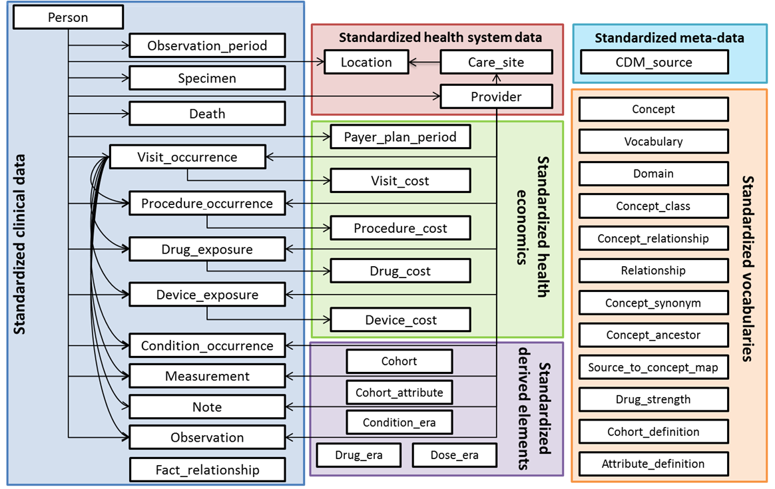

## Appendix 2: OMOP CDM Version 5.0 ERD

Standardized Vocabularies entity-relationship diagram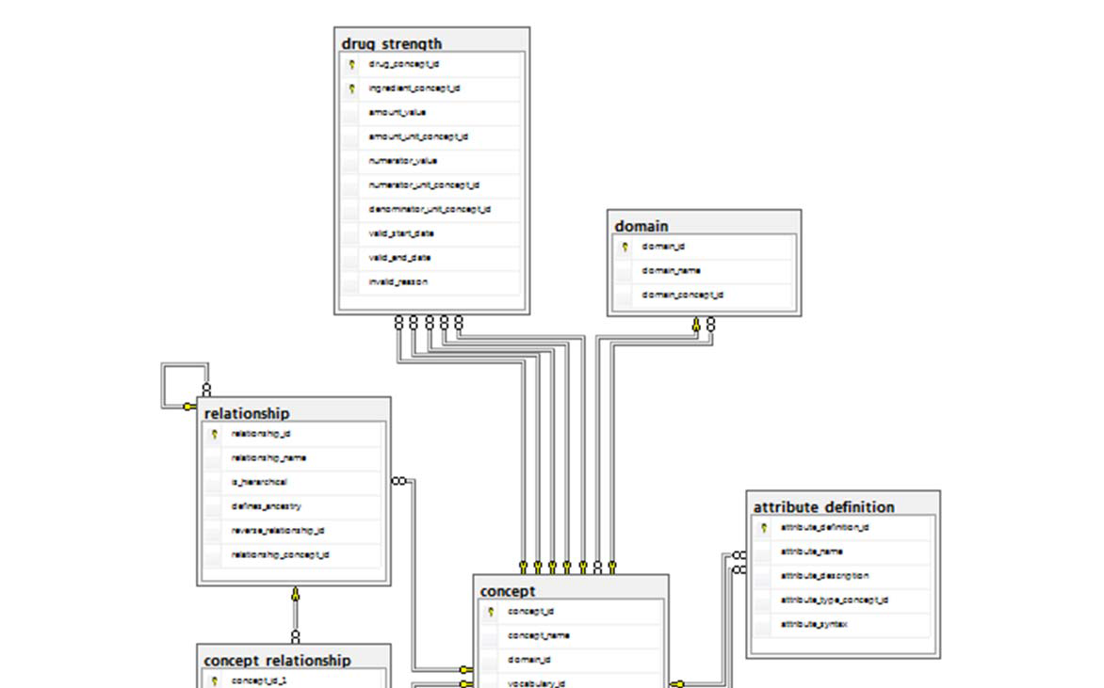 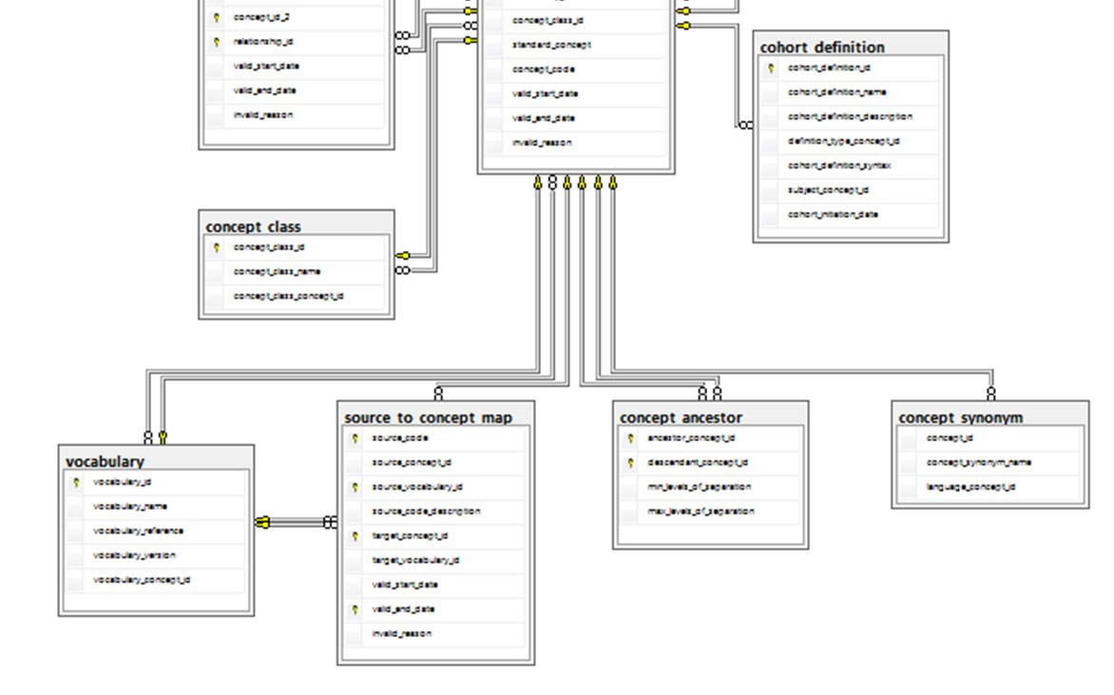

Standardized Clinical Data Tables Entity Relationship Diagram

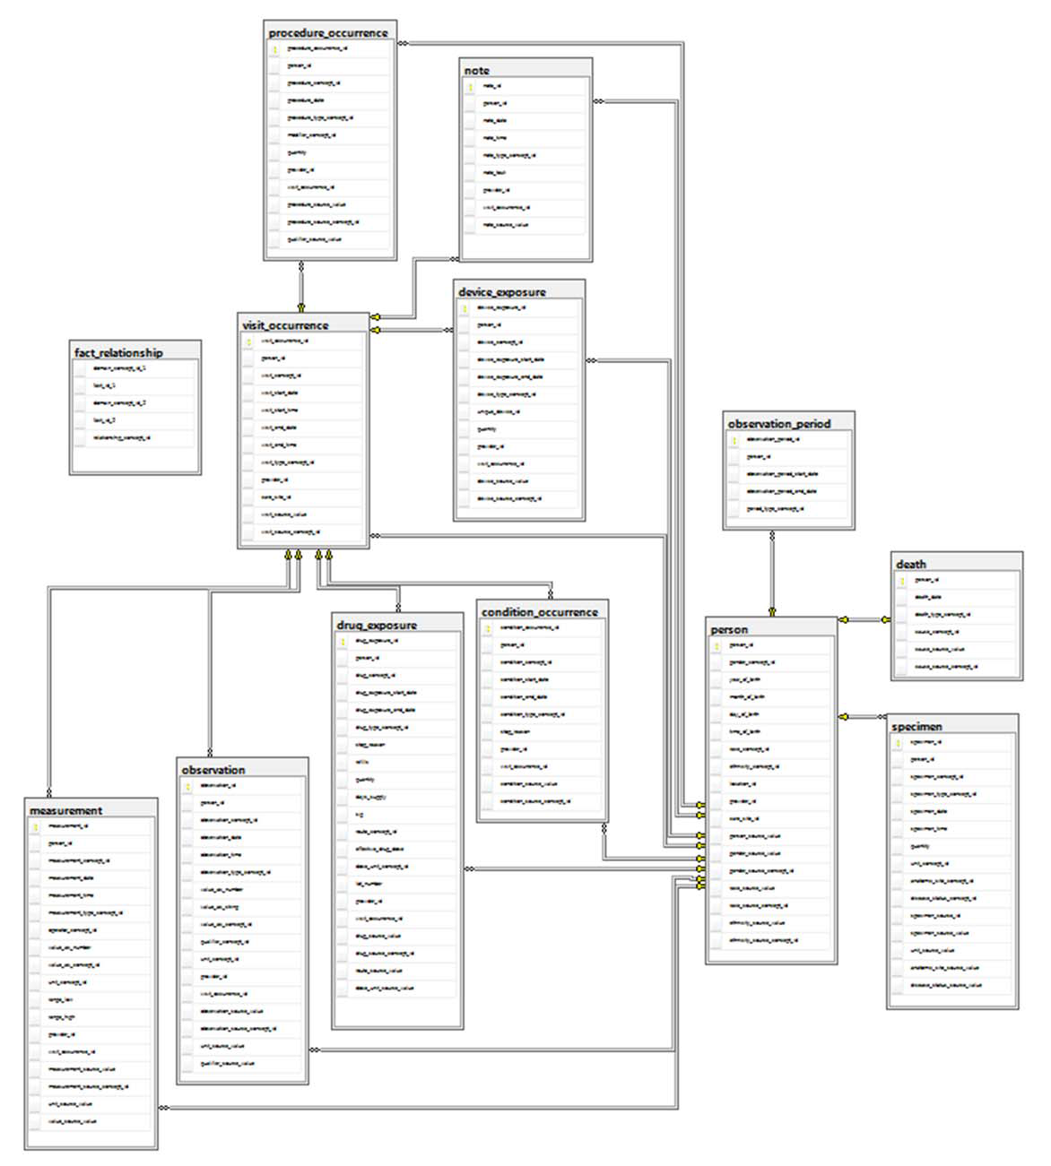

Standardized Health System Data Entity Relationship Diagram

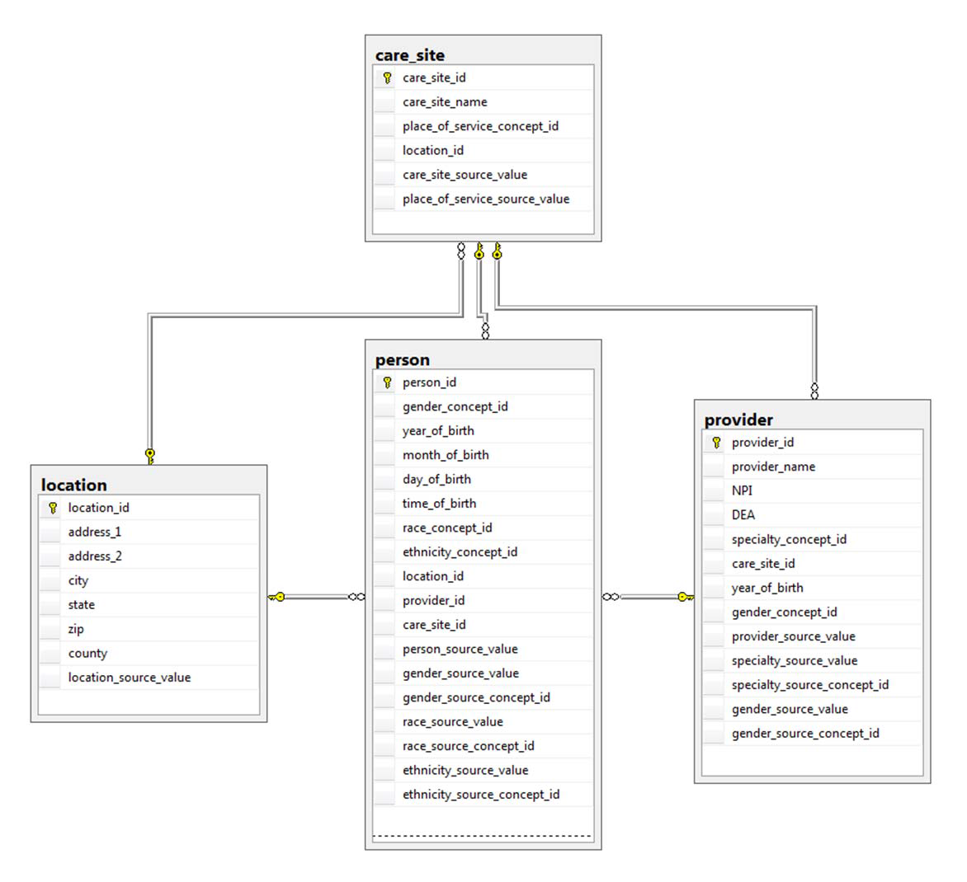Standardized Health Economic Data Entity Relationship Diagram

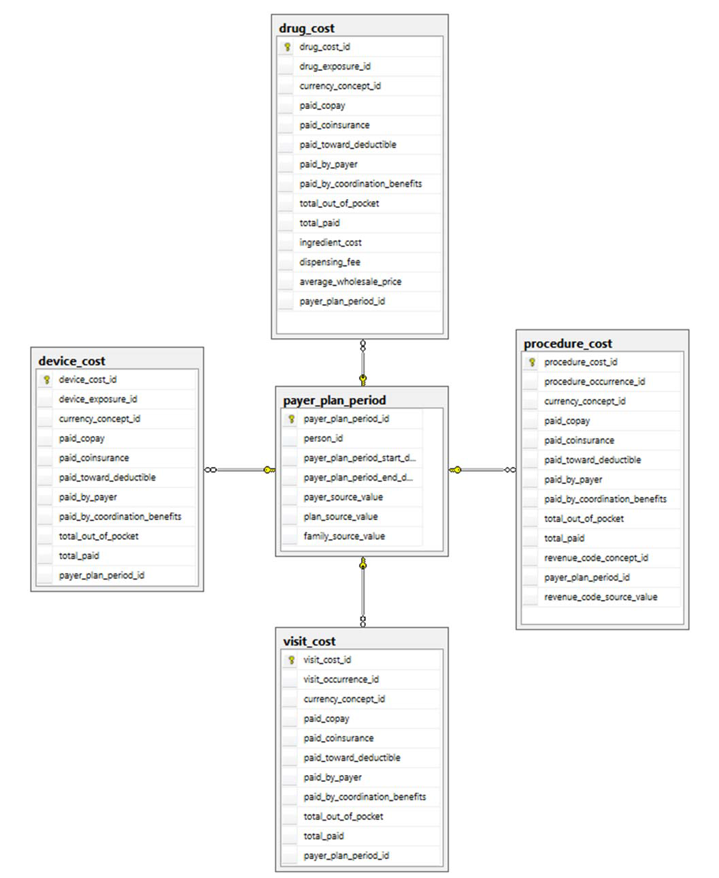Standardized Derived Elements Entity Relationship Diagram

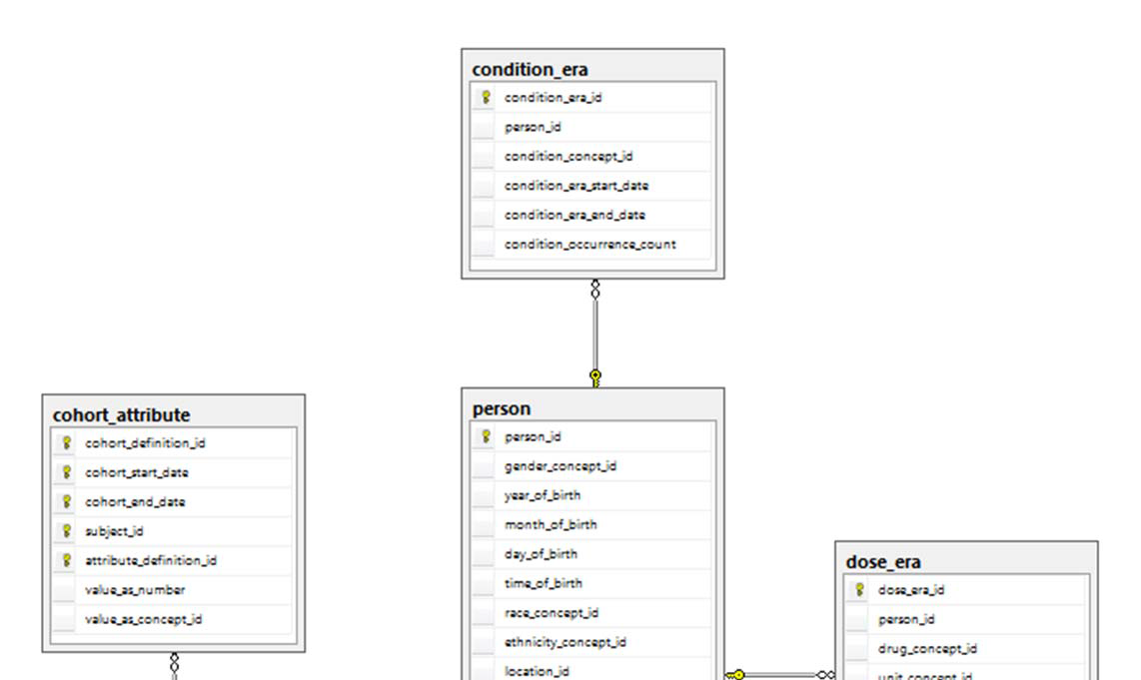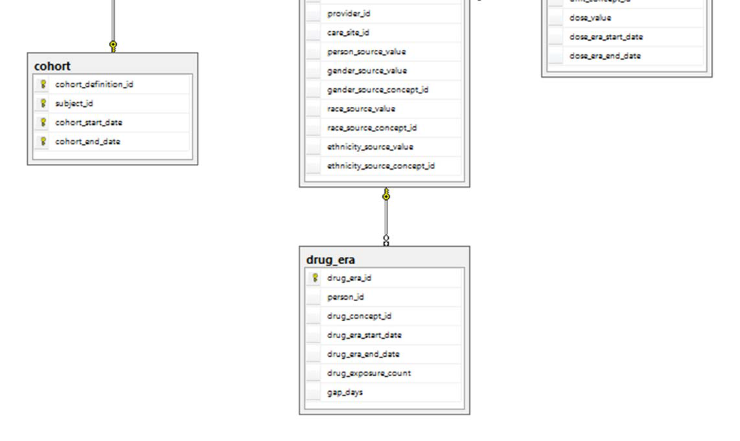Standardized Metadata Entity Relationship Diagram

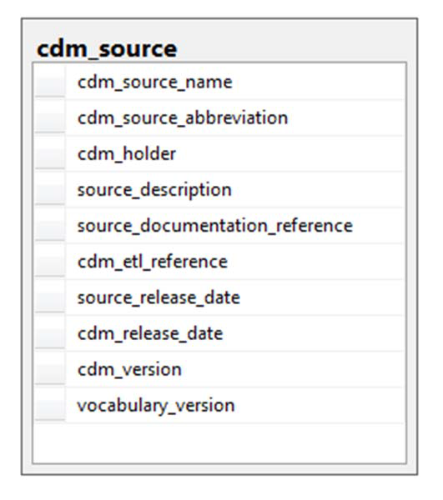

# Outstanding Issues

Immediate

1. Check with Chris is concept 44814723 has been corrected: ‘Period while enrolled in study’ should be changed to ‘Geography based’.

Parking lot

TBD: Enrollment Period: PCORNet table could be sourced from either the Observation_Period or the Pay Plan Period in OMOP. Derviing from Pay Plan Period needs to be done.

1. TBD: Do we transfer to PCORI ‘invalid’ DX’s? For example ‘250.x’ Indicates diabetes but it is not a valid ICD9 code. Those will be stored in OMOP with source_concept_id=0. If yes, will we have DX_TYPE of ‘Other’? Need PCORnet feedback